# **Name: Abdurrahman Qureshi**

# **Roll No: 242466**

Assignment No: 2

Aim: Design a network for an organization using the concepts of Addressing (IP Address Assignment, Naming (DNS) and Routing. Also mention the internetworking devices used.

Devices Used:

1. Router (R1) :

Function: Connects multiple subnets and routes traffic between different departments.

Interfaces & IPs:

* Fa0/0 → 192.168.3.1 (CO Department)
* Fa1/0 → 192.168.2.1 (IT Department)
* Fa1/1 → 192.168.4.1 (Civil Department)
* Fa0/2 → 192.168.1.1 (Server Network)

2. Switches (Layer 2 Devices)

Function: Provides LAN connectivity within each department.

Switch List:

* SW1 (IT Department) – Connected to PCs 192.168.2.2 & 192.168.2.3
* SW2 ( Server Network) – Connected to Server 192.168.1.100
* SW3 (CO Department) – Connected to PCs 192.168.3.2 & 192.168.3.3
* SW4 (Civil Department) – Connected to PCs 192.168.4.2 & 192.168.4.3

3. End Devices

* PCs: Represent users in different departments.
* Server: Located in 192.168.1.100 (likely used for DNS, web, or database services).

4. Network Topology & Concepts Used :

* IP Addressing: Each department is assigned a unique subnet.
* Routing: Router R1 is handling communication between different subnets.
* DNS : The server (192.168.1.100) might be used for domain name resolution

For IP Addresses & Interfaces:

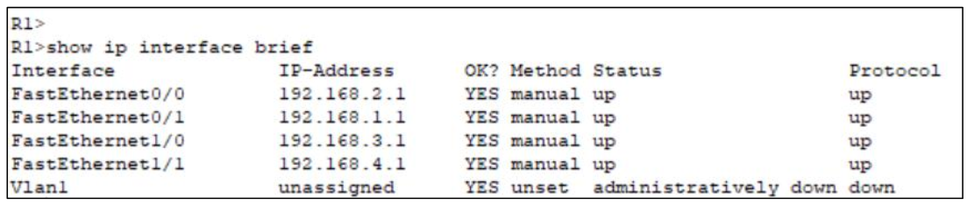

For Routing Table:

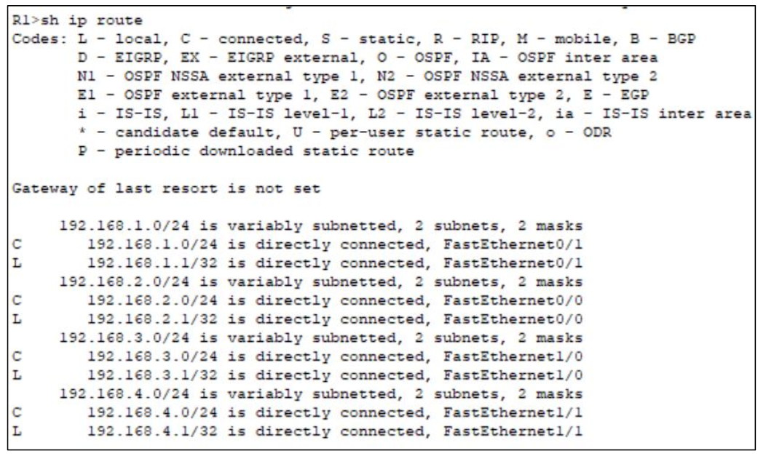

For DNS Configuration:

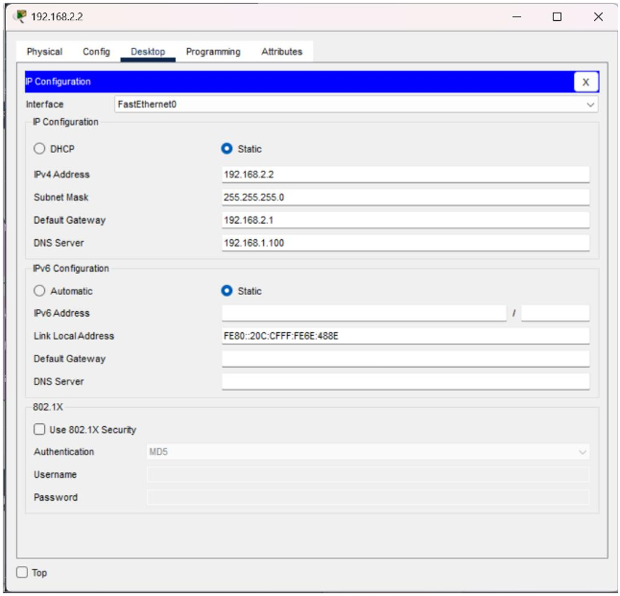

Small Network Organisation For College:

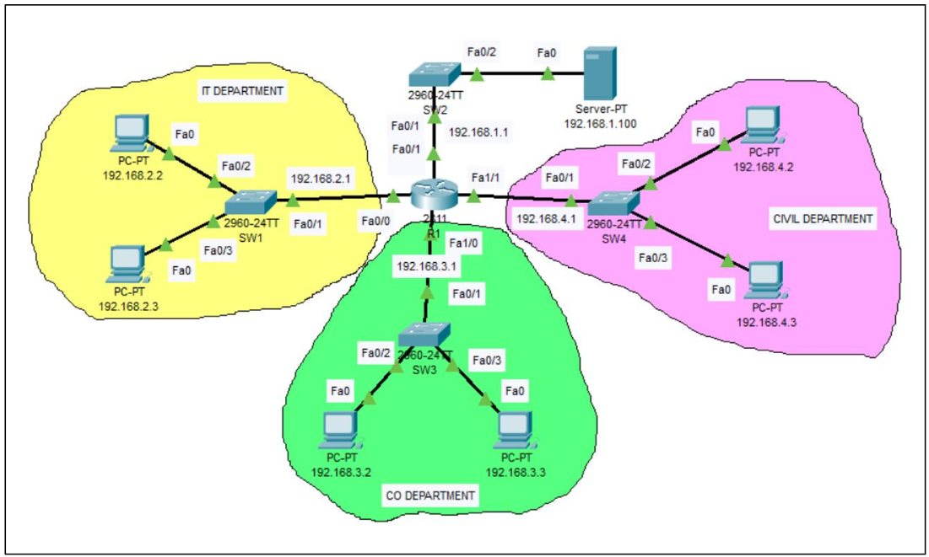

OUTPUT:

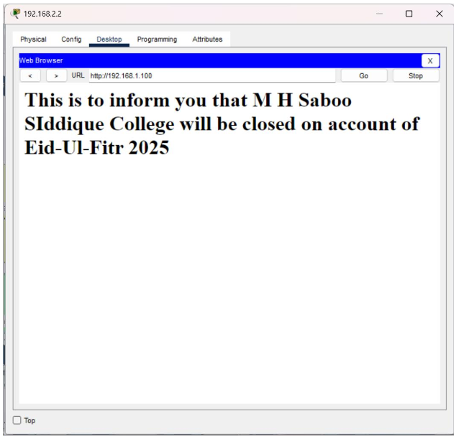

Conclusion:

A well-designed network for an organization ensures efficient communication, security, and scalability. Proper IP addressing (static for critical devices, dynamic for others), effective DNS for name resolution, and appropriate routing protocols (static or dynamic like OSPF/EIGRP) optimize data flow and connectivity. Internet-working devices such as routers, switches, firewalls, and load balancers provide connectivity, security, and traffic management. Overall, this design enhances performance and supports the organization's future growth and operational needs.